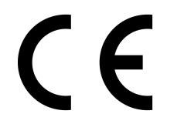
Intra Materialhantering AB, Truckvägen 2, SE-231 62, Trelleborg, SWEDEN
Manufacturer or his authorized representative in Community

Type | Serial No.
1340057760
HFJ-400A, Forklift Jack, 4 Ton

1340057762
HFJ-700A, Forklift Jack, 7 Ton
Authorised signatory

Anders Hylén
Trelleborg 2024/02/26

EU DECLARATION OF CONFORMITY

The signatories hereby certify that the specified product conforms to the EU Directive 2006/42/EC (Machine Directive) including the amendments as translated into national legislation of the member countries. The signatories are in each case individually authorized to compile the technical documents.

